**What comparisons can be drawn between Palestine-Israel and elsewhere?**

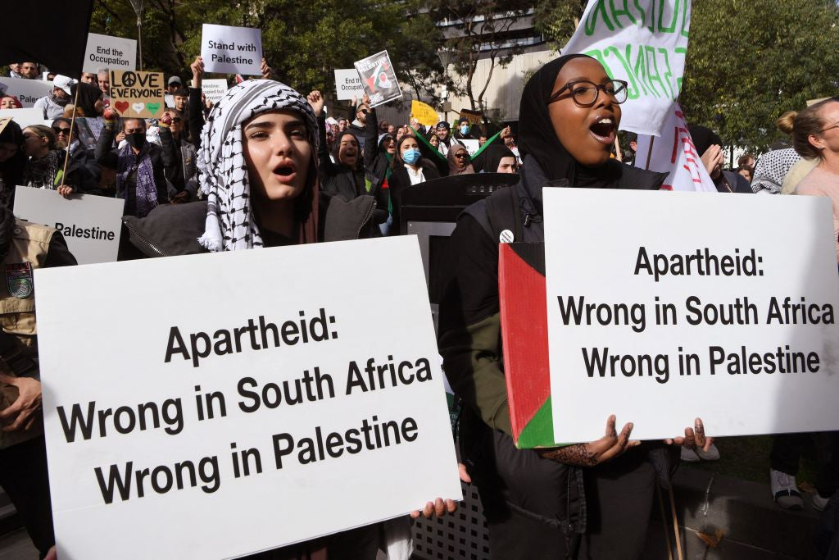

**By the end of this lesson, you should be able to:**

Draw comparisons between Palestine-Israel and other places

Discuss whether or not the situation in Palestine-Israel is exceptional

**Keywords**

Racism

Colonialism

**Keywords activity**

1.Use the glossary at the back of your book to pick 3 keywordsthat characterise the situation in Palestine-Israel

2.Are there any other words that you could use to characterise the situation in Palestine-Israel?

**Keywords**

**Racism**: hostility, prejudice or discrimination against someone based on their race

Discrimination

Occupation

Settlements

Ethnic cleansing

Apartheid

**Activity**

Pick 1 or 2 of the keywords above and write a few sentences explaining why this can be used to summarise the situation in Palestine-Israel

**Why is it helpful to draw comparisons?**

Comparison is a valuable tool. It brings to light similarities and differences and can help us to understand a situation better. Comparison can also help us to find solutions to problems

**Similarities and differences activity**

Read through the two case studies below:

Case Study 1: Apartheid in South Africa

Case Study 2: The Srebrenica Genocide

Using what you already know about Palestine-Israel and its history, what **similarities** and **differences** can you see with events in South Africa and Srebrenica?

**Case Study 1: Apartheid in South Africa**

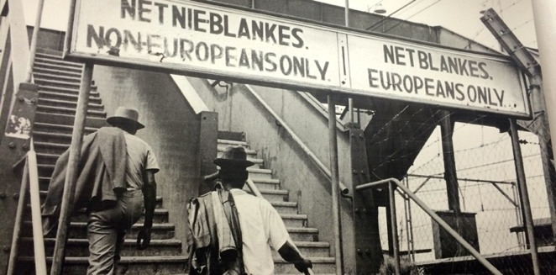

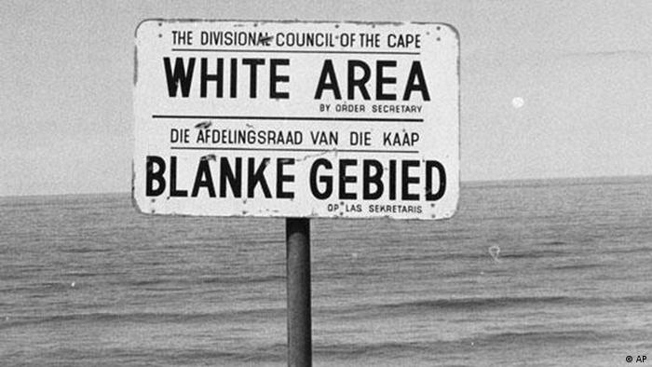

South African apartheid lasted from 1948 until the 1990s. Under apartheid, white and non-white South Africans had to live in **separate areas**. Contact between the two groups was very limited and non-white South Africans had to carry **documents** to prove that they were allowed in certain areas. Millions of non-white South Africans were **forcibly displaced** from their homes during the apartheid era

When it comes to Palestine, as we saw last lesson, leading international human rights organisations now agree that Israel is committing the crime of apartheid against the Palestinians. Across Israel and the occupied Palestinian territories there is a system of separation based on race. This includes discriminatory laws, policies and practices

Using this information, fill in this table in your book:

**Case Study 2: The Srebrenica Genocide**

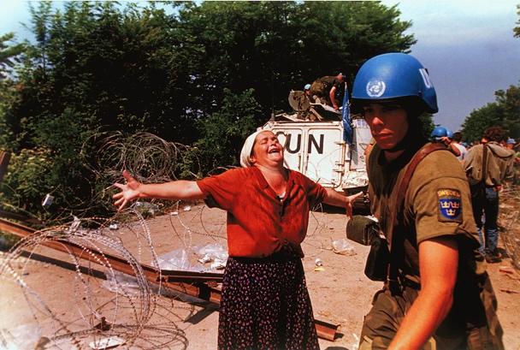

Srebrenica is a town in Bosnia and Herzegovina in southeastern Europe. The Srebrenica Genocide took place between 1992 and 1995 in the wider context of the Bosnian War. The Srebrenica Genocide was the first genocide in Europe since World War Two

In 1995, **8000 Bosnian Muslim men** were killed and 30,000 Bosnians faced systematic forced removal from their homes. Like with the Nakba of 1948, this is an example of **ethnic cleansing** -the systematic forced removal of an ethnic, racial or religious group from a particular area

During the Nakba, 15,000 Palestinians were killed in a series of mass atrocities, including more than 70 massacres. 750,000 Palestinians were forced to leave their homes - half of the Palestinian population. Today there is an ‘ongoing Nakba’ as Palestinians continue to be forced out of their homes by Israeli apartheid policies

Using this information, fill in this table in your book:

**What other comparisons can be drawn with Palestine-Israel?**

The Rwandan Genocide: between April and July 1994 in the context of the Rwandan Civil War, 800,000 individuals (mostly Tutsis) were killed in around 100 days. This is another example of **ethnic cleansing**

Parallels between the situations of Palestinians and Black Americans.

Black Americans and Palestinian citizens of Israel are…

**-three times more likely** to live in poverty than White Americans and Jewish Israelis

**-one third less likely** to gain a college education than White Americans and Jewish Israelis

**-significantly more likely** to be unemployed than White Americans and Jewish Israelis

On average, Black Americans and Palestinian citizens of Israel receive **one quarter less** annual income than White Americans and Jewish Israelis

*Can you think of any other comparisons that can be drawn?*

**Debate activity**

*Key question: Can the situation in Palestine-Israel be compared to elsewhere or is it* ***exceptional****? (Exceptional: unusual, not typical)*In this debate you will either be ‘**comparable**’ or ‘**exceptional**’. Spend a few minutes preparing your argument  
  
Note down any good points made by the other side

**Questions**

What was the best point you made?

What was the best point made by the opposing side?

Which side had a stronger argument?

Do you think Palestine-Israel is comparable to other places or exceptional? Why?

**Extension activity**

Write one paragraph answering this question. Remember to justify your answer.

*Is the situation in Palestine-Israel exceptional?*